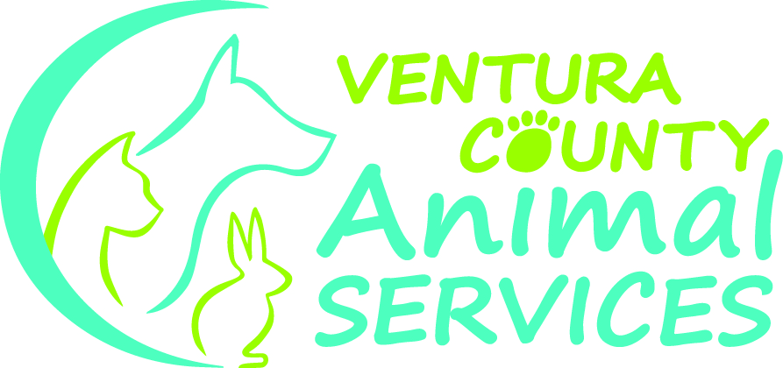

Tara Diller
Director

Donna Gillesby
Deputy Director

Joan R. Araujo
Deputy Director
VCMC Ambulatory Care Administrator
Compliance Officer

Sheila Murphy
Public Information Officer

Dee Pupa
Deputy Director
Managed Care
Patient Accounting

Narcisa Reyes-Egan
Interim Chief Financial Officer

Tim Rhyne
Health Care Agency
Human Resources Director

Jon J. Smith, MD
Medical Examiner

Terry Theobald
Information Technology Director

Rigoberto Vargas
Public Health Director

Ventura County Animal Services Commission
Regular Meeting
Meeting Minutes June 25, 2015

1. Call to Order

2. Roll Call

Members Present: Councilmember Kevin Kildee – City of Camarillo, Councilmember Carmen Ramirez – City of Oxnard, Councilmember Douglas Breeze – City of Port Hueneme, Mayor Janice Parvin – City of Moorpark, Councilmember James Monahan – City of San Buenaventura, Councilmember Randy Haney – City of Ojai, Supervisor Steve Bennett – County of Ventura (arrived late @ 9:10 a.m.), Board of Supervisors.

Absent: Councilmember Glenn Becerra – City of Simi Valley and; Mayor Pro-Tem Diane McCall – City of Fillmore.

Staff present: John Brand – City of Moorpark, Rick Murray – Ventura Police Dept., Randy Friedman – Animal Services, Beth Pattee – WhatCanWe.org, Terri Yanez – County of Ventura CEO, Jennifer Santos – City of Simi Valley, Mark Westerline – City of Moorpark, Kathryn Rutherford – Tiny loving canine Volunteer, Desiree Nelson – TLC Board Member, Linda Nelson – TLC Director, Mark Oyler – City of Simi Valley, Roger Pichardo – City of Camarillo, Tamah Figg – City of Port Hueneme, Officer Aaron Ortega – Animal Services.

3. Flag Salute

4. Approval of Minutes: Minutes from the Meeting of the Ventura County Animal Services Commission held April 9, 2015.

Motion: Approve Minutes.
Moved by Mayor Janice Parvin, to approve minutes, motion seconded.

5. Public Comments: (None)

6. Continued Business: (None)

7. New Business:

  - Proposal for License Amnesty for July/August – Deputy Director Donna Gillesby gave a presentation regarding the Animal Licensing Amnesty campaign. The campaign is to be run from July 1st to August 31st, 2015. During the campaign, all penalties of licenses will be pardoned and emphasis on obtaining first time licenses will be encouraged to avoid future penalties and citations. During this campaign VCAS will also introduce its new license structure. Deputy Director Gillesby explained how this campaign will be rolled out and who will be participating.

Direct Diller stated that there is a misconception that the County and Cities will be losing the revenue from the late fees. It was explained that we are already losing this revenue because people are not coming in due to hardships. That it is a way to bring animal owners back into the system. There was a discussion on how this will affect the homeless population. Deputy Director advised that we do not charge the homeless population for their licenses and rabies vaccines. Pets of the identified homeless must be spayed and neutered in order to receive this benefit. VCAS does not charge for the surgery.

Mayor Parvin – City of Moorpark, shared her concerns regarding how this would affect the City of Moorpark. It was decided that Moorpark would take the discussion back to their City Council for approval.

Motion to accept proposal for License Amnesty for July/August made by Councilmember Monahan. Seconded by Councilmember Breeze.

Ayes: 6 Nays: 1 Motion Carries.

  - Mandatory Spay Neuter – Deputy Director Gillesby updated commission regarding making revisions to the Mandatory Spay/Neuter Ordinance and requested all cities to move forward with supporting this ordinance. Councilmember Ramirez stated that the City of Oxnard would be revisiting this issues, she shared her concerns about the unintended consequences involved with the Mandatory Spay/Neuter ordinance. Director Diller stated that these consequences are a direct result from enforcement on the street and reiterated that an educational approach be taken. Deputy Director Gillesby offered to sit down with City of Oxnard staff and discuss ordinance.

There was additional discussion from other cities regarding the processes of passing this ordinance and the new costs of their city contracts. Supervisor Bennett advised cities that VCAS has been leveraging volunteer services, donations and other resources to keep cities costs down. He requested that cities at least try and have discussion within themselves by January 2016. Supervisor Bennett stated that this is one of the ways to keep the intake numbers down to remain “No-Kill.”

Motion to accept taking the Mandatory Spay/Neuter ordinance back to their respective cities for discussion by January 2016 made by Councilmember Monahan. Seconded by Councilmember Breeze.

Ayes: 7 Nays: 0 Motion Carries.

  - Closing the shelter once a month for deep cleaning - Deputy Director Gillesby shared with the Commission that both VCAS shelters will be closed the third Wednesday of every month for deep cleaning and maintenance. Director Diller further shared that it doesn’t affect people looking for their dogs, or bringing in animals, that only adoptions are affected. There was a discussion about how the public is being notified about the closure. There was a question about being closed every two (2) month vs. every month. Deputy Director Gillesby stated that this is on a trial basis and if VCAS sees that it is not necessary to close once a month VCAS will closed every other month. She further advised that field services and phone services will still be available.

Motion to approve the shelter closing once a month on a tentative basis made by Councilmember Breeze. Seconded by Councilmember Ramirez.

Ayes: 7 Nays: 0 Motion Carries.

8. Director’s Report:

- Director Diller briefed the Commission on the status of contract negotiations. First round of contract negotiations are complete. She had attended most city council meetings. There was a discussion about contract increases. Director Diller advised that she sent an email about the “working group” meetings regarding the contracts, but received no responses. Director Diller’s proposal was to start meeting sometime in September to begin these working groups to discuss intakes and other cost saving matters. She instructed her assistant, Sandra Ropes to re-send email.

Director Diller continued with VCAS taking cost-saving measures in a couple of ways; the Management Assistant retired two weeks prior and the position was downgraded two (2) steps and Sandra was brought in. Microchip vendor has been changed from InfoPet to Found Animals, out of Los Angeles. The cost is 50% less. These new microchips are automatically registered on the owner’s behalf. Animal owners are able to make changes to their chip information (there is no fee for them to update information) thus helping VCAS return animals to their families. The Found Animals system also provides some automatic services, such as notifying owners and veterinary offices. There was a discussion about processes for found, impounded, and surrendered animals.

Director Diller responded to questions about surrendered animals. She gave several reasons for this happening. Director Diller advised the Commission that, among the new projects in the works, is the Pet Retention Coordinator position. A fund has been established from the County of Ventura to assist with pet deposits for rental properties. She stated that VCAS will be implementing an “appointment to surrender your pet” system so that VCAS may get to the root of the issue as to why animal owners are truly surrendering their pets and provide help and information to retain their pets. There was a discussion about VCAS’ relationship with Veterinary offices in the County of Ventura.

Director Diller stated that there are some planned improvements to the Camarillo and Simi Valley shelters. There has been a $1.2 million contribution by the County and the cities will not be asked to reimburse these costs. There are planned improvements in the isolation building at the Camarillo shelter, backyard improvements at the Simi Valley shelter, Adoption center in Camarillo, noise reduction panels, and a compassion fatigue seminar are planned. Moneys from grants, donations and funds form the County will pay for these improvements. Supervisor Bennett stated that this is a good example of how VCAS is using donations and funds to leverage the costs of operating the shelters.

Randy Friedman, in charge of Marketing and Media was introduced. There was a discussion about having the military participate in shelter projects. There is a group coming in to plant lavender throughout the shelter.

A Compassion Fatigue workshop is planned for staff. Summer promotions are in effect. Fourth of July pet tips have been posted on Facebook. Cities were asked to please forward and put on their city pages.

9. Commissioner Comments:

There was a discussion about the dog of the year and the cat of the year in the news. Perhaps VCAS can make nominations. There was a suggestion about participating in the Fair parade and having a booth at the Fair by Councilmember Monahan.

Director Diller advised that VCAS’ first signature Gala is happening on Saturday, September 12, 2015, at the World War II Camarillo Airport museum. It will be a 40’s themed event and is called, “Canine Casablanca, a Rescue Affair.” Tickets sales are $225 per couple and can be purchased via PayPal. VCAS is hoping a puppy playground and education room can be built with proceeds from this event. There was a brief discussion about ticket sales. Capacity for this event is 300 to 325 persons.

Director Diller also informed the Commission that there had been a launch party for VCAS’s PitCrew in connection with Ventura Harley Davidson. A new website was developed to help dispel myths about pit bulls and owning pit bulls. The long term goal is to secure a group of volunteers that work exclusively for the shelters’ pit bulls residents.

Mayor Parvin advised that she attended an event in Moorpark. She spoke about different things and when she spoke about VCAS as a no-kill shelter, everyone was very receptive and had wonderful things to say.

Director Diller advised that a donor from Westlake Village wants to donate $80,000, on the condition that VCAS is no-kill and trying to be a national model. Director Diller stated that VCAS is receiving calls from other counties and they want to come to visit us to see how VCAS doing the “No-Kill” and to learn from the shelter.

Supervisor Bennett spoke how far VCAS has come in such a short time. He commented about what a great job staff has done. He thanked everyone for their work and the cities for “hanging in there.” He feels that Government’s job is to reflect the core values of their community and that the shelter has done this for Ventura County.

Councilmember Ramirez thanked Tara for her work, but especially wanted to thank the volunteers for their work. Supervisor Bennett advised that staff has been recognized at the Board of Supervisors.

10. Adjournment: Meeting adjourned at 10:27 a.m. Next meeting is Thursday, September 10, 2015.

